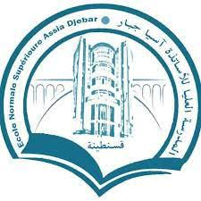

NCAMD 2021

NCAMD 2021 CONFERENCE REGISTRATION FORM
19 June 2021, Constantine, Algeria

First Name: Last Name:

Academic degree: Pr MCA MCB Doctoral Student

University:

Theme of the presentation:

Title of the presentation:

